Ques 3
Spark
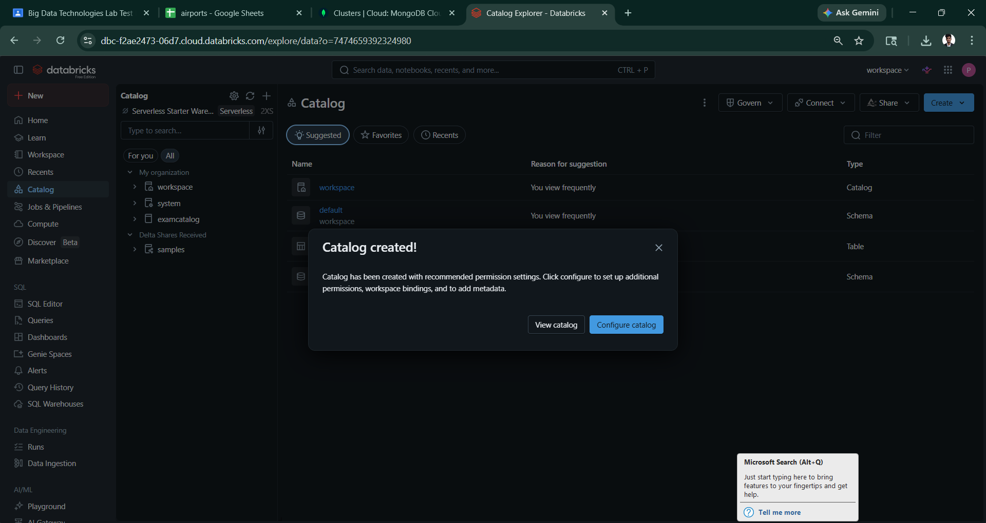
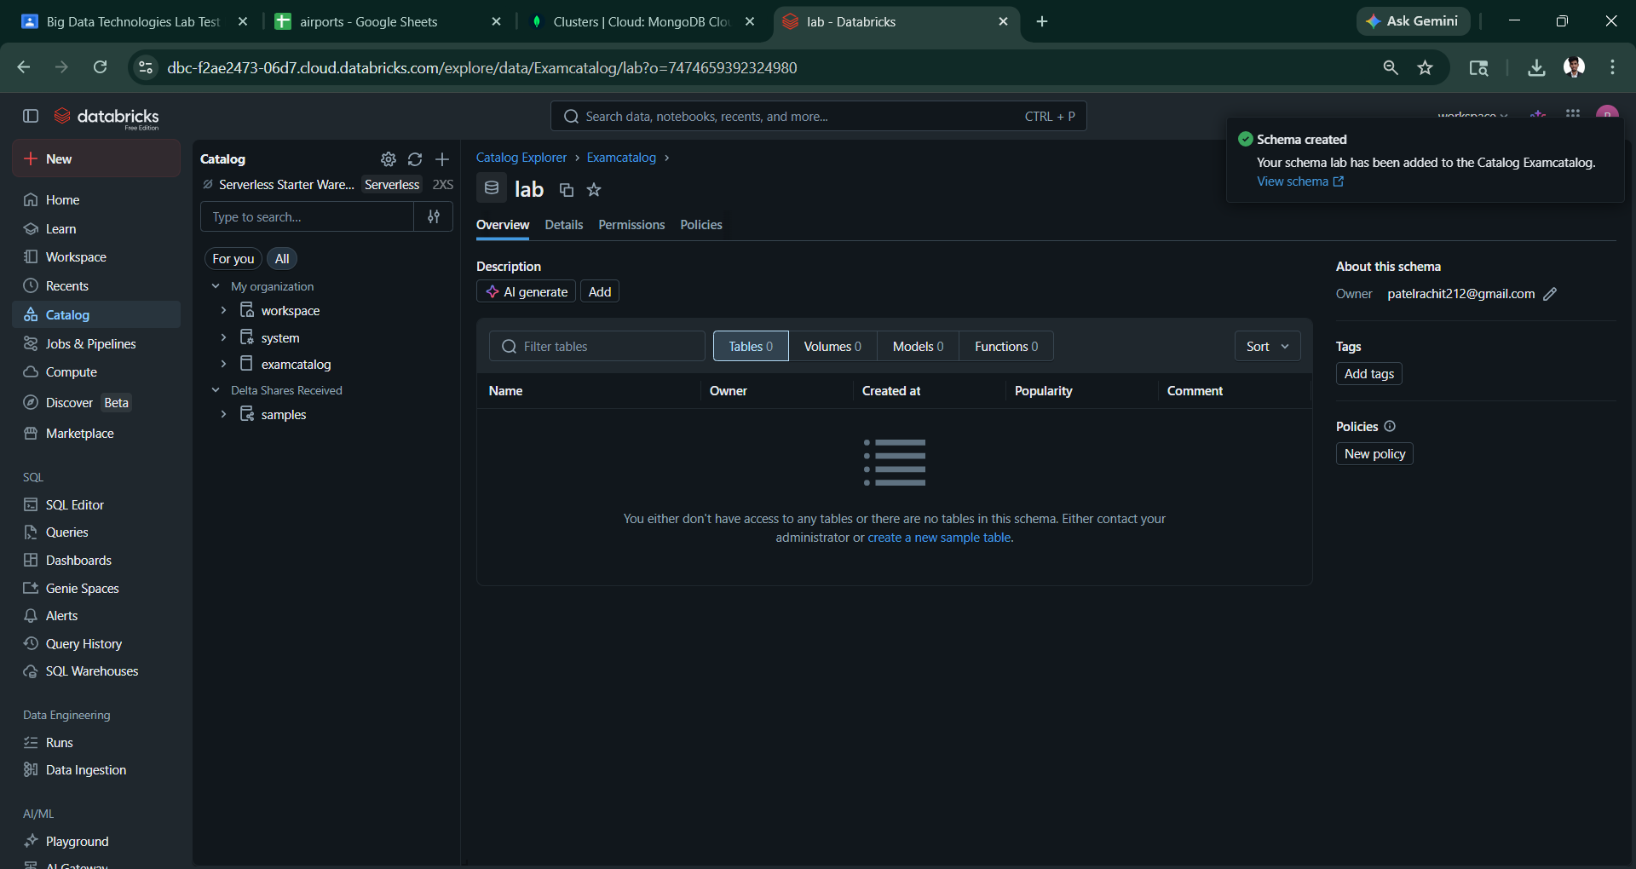
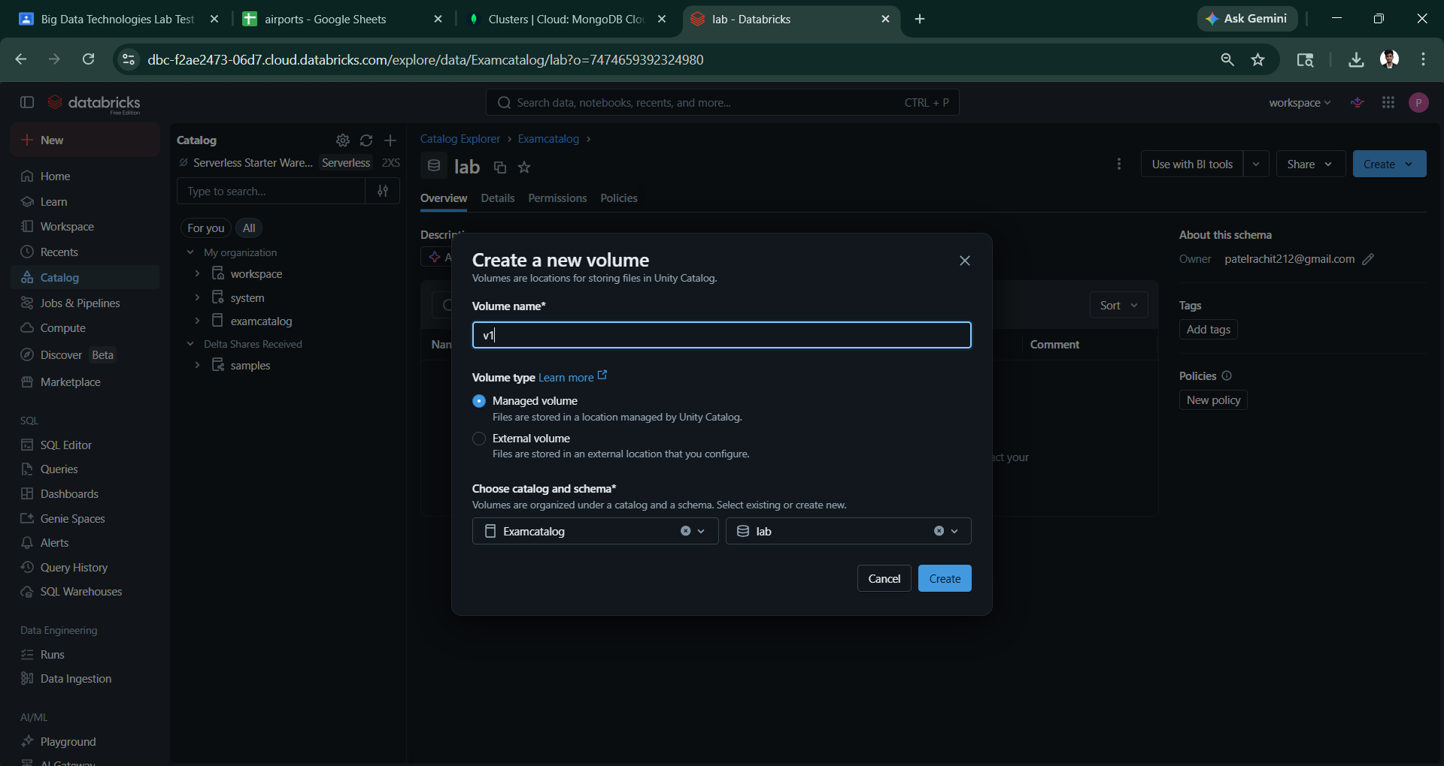
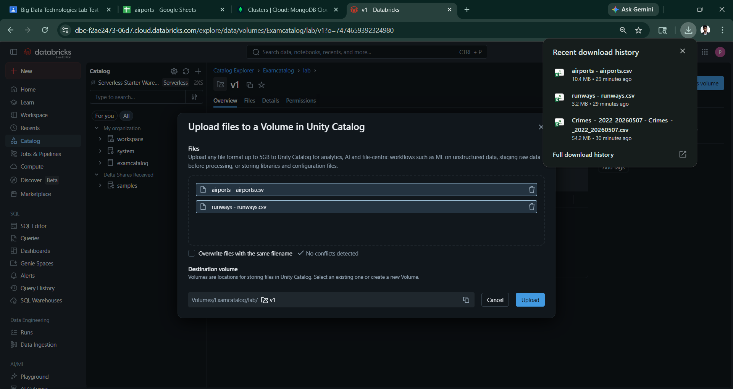

I have uploaded two csv in volume v1 then
Part A:
h. l loading the files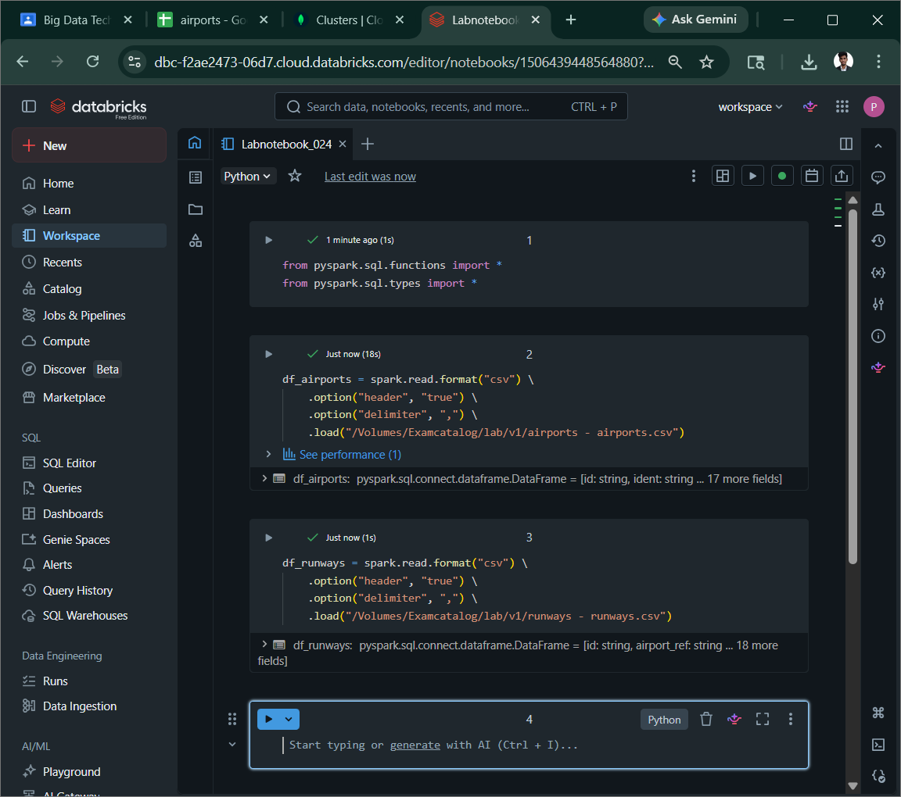

- To cast columns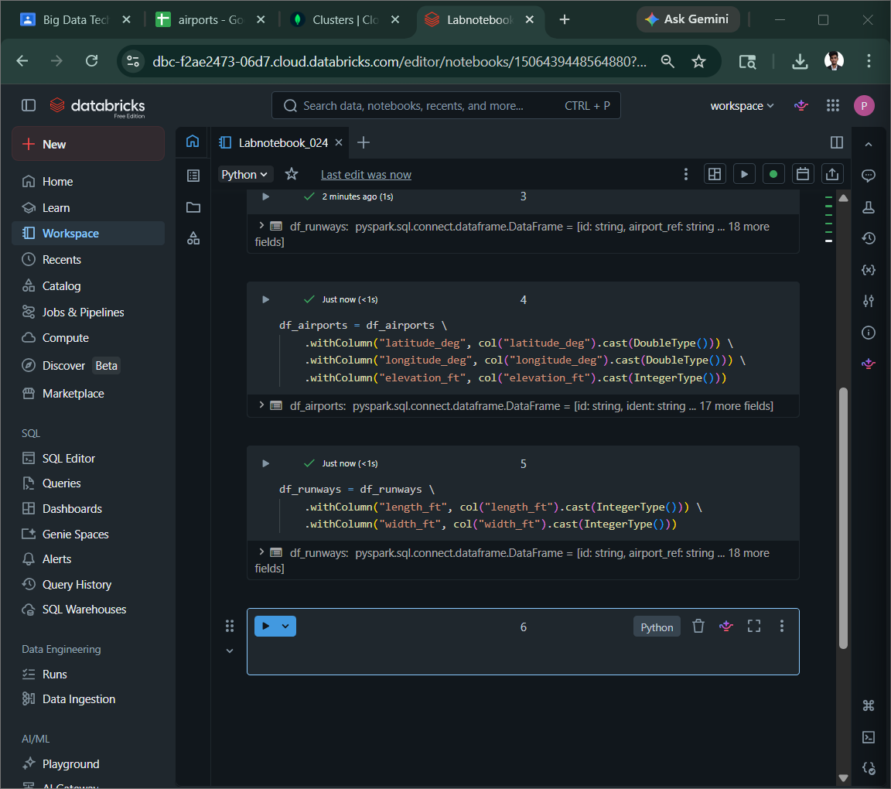

j. print the scehma and row count of both the dataframesz
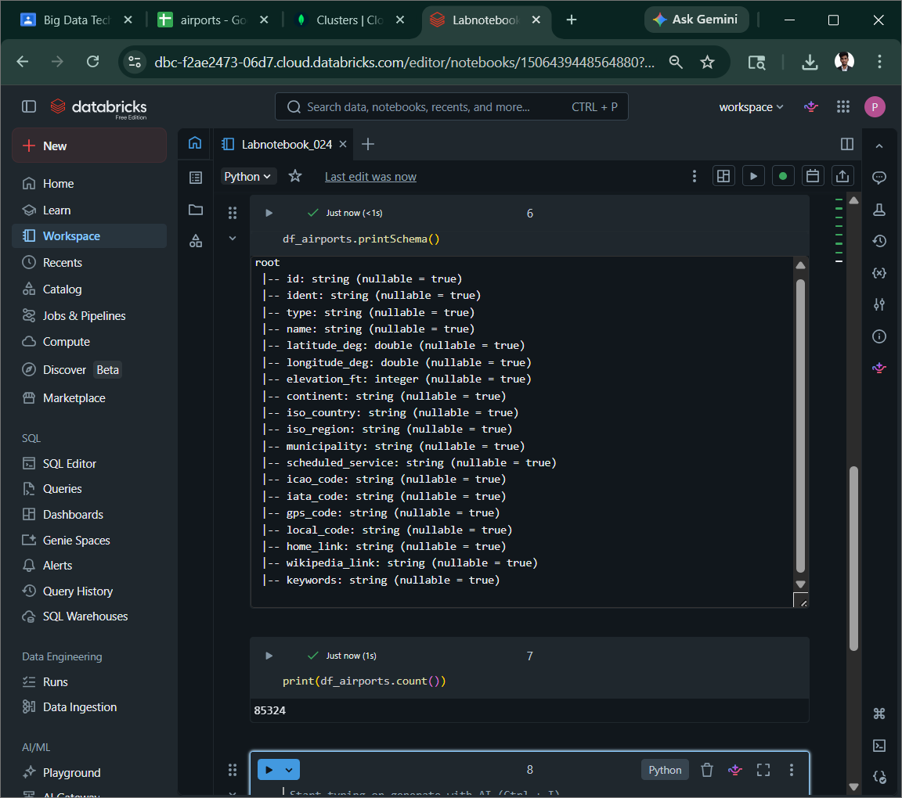
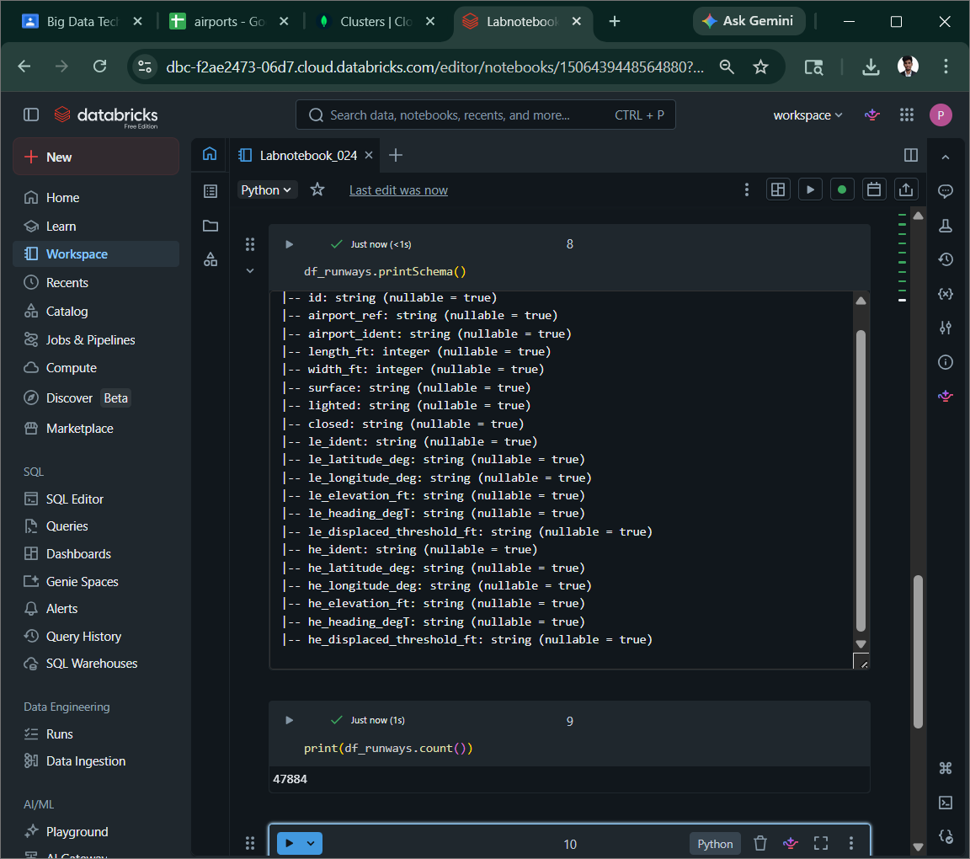
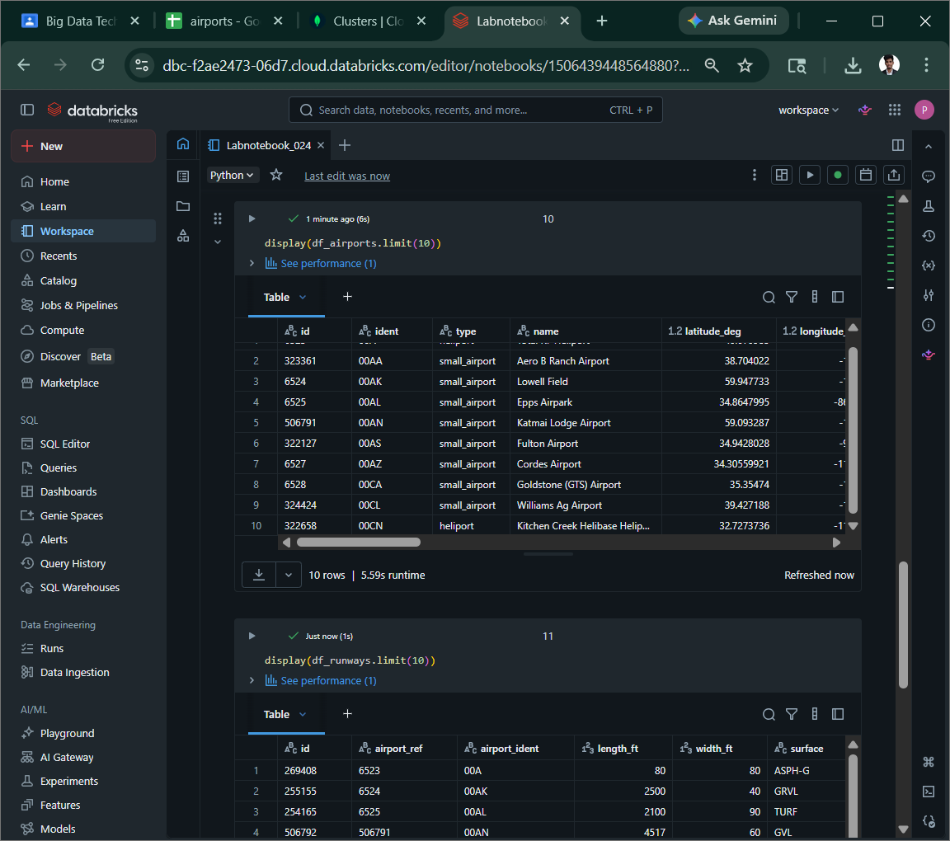

part b
k. join df_airports with df_runways of the airport identifier colum (ident in df_airports matches airport_ident in df_runways ) using an inner join . name the result df_combined
l . add a new colum runway_category based on length_ft :”Long” if >=10000ft. “Medium” if between 5000 and 9999 ft and “short” if below 5000 ft
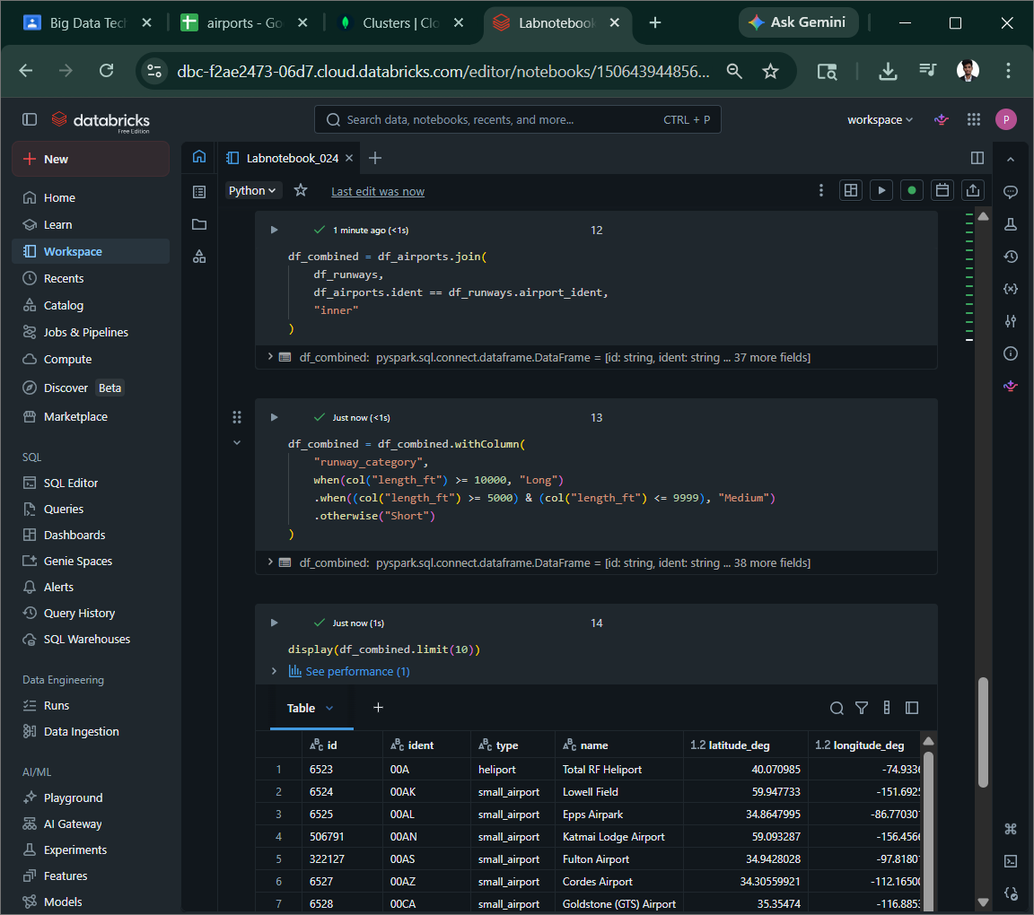
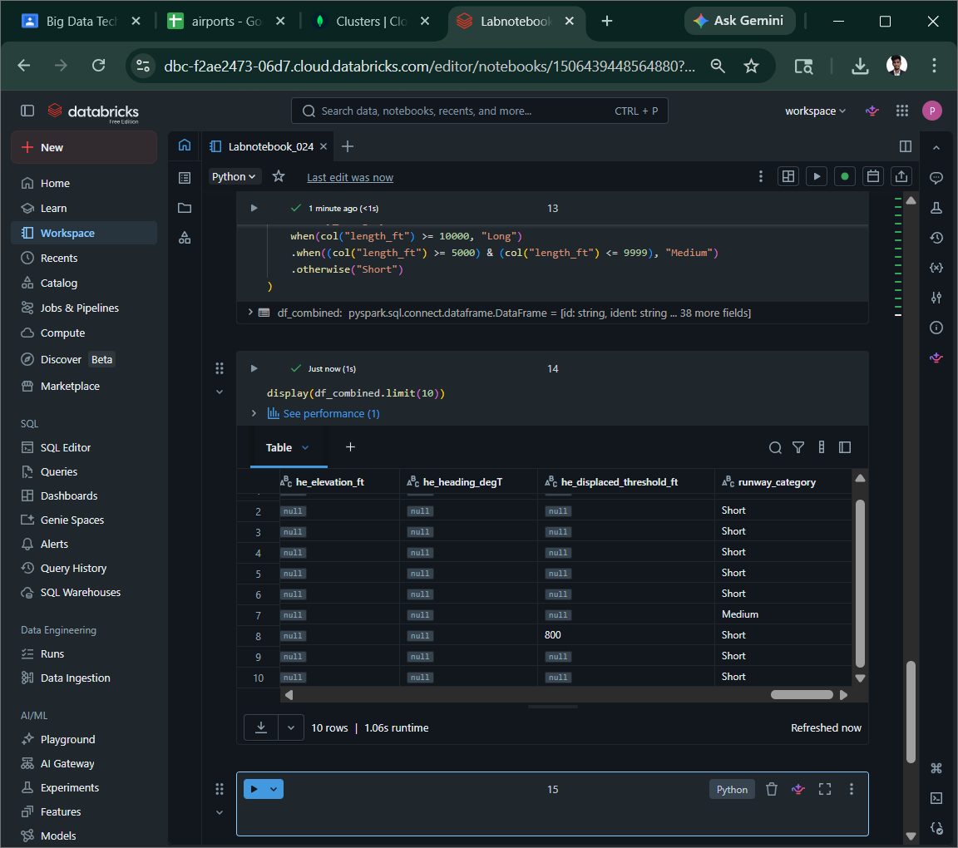
part c analysis
create a temporary view named airports_view from df_combined and and write the following sql queries.
14. find the top 10 countries (iso_country) with the highest number of runways .diplsay country code and runway count,ordered descending
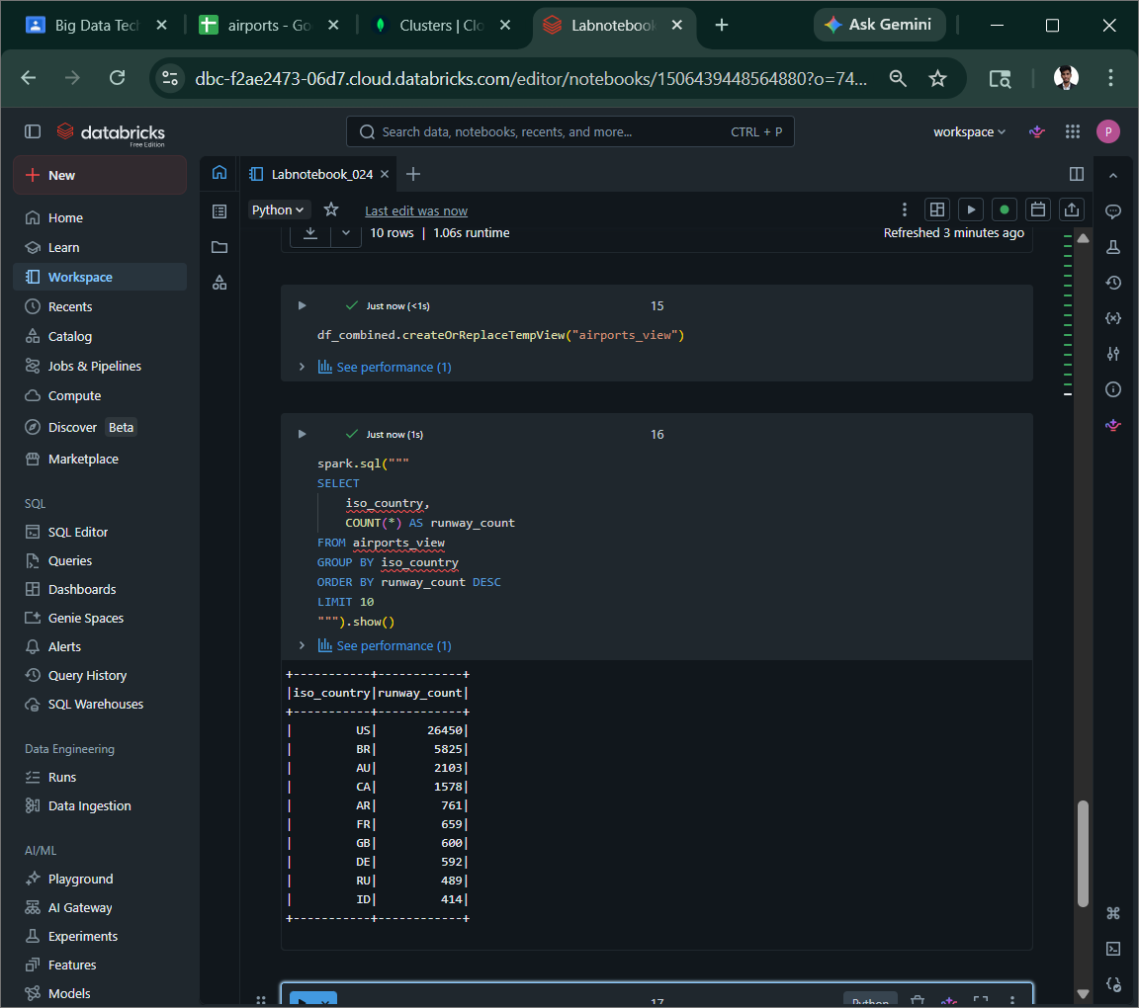
15. Find the average runway length (length_ft) per contient .Exclude rows where length_ft is null.Order by average length descending

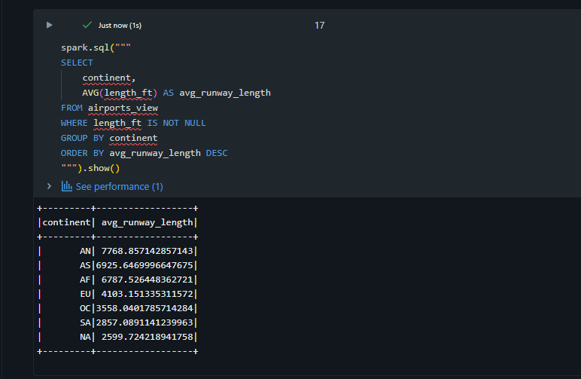
16. Find all airports in india (iso_country-“IN”) that have at least one lighted runway (lighted=”1”)Display the arport name , municipality and number of lighted runways.
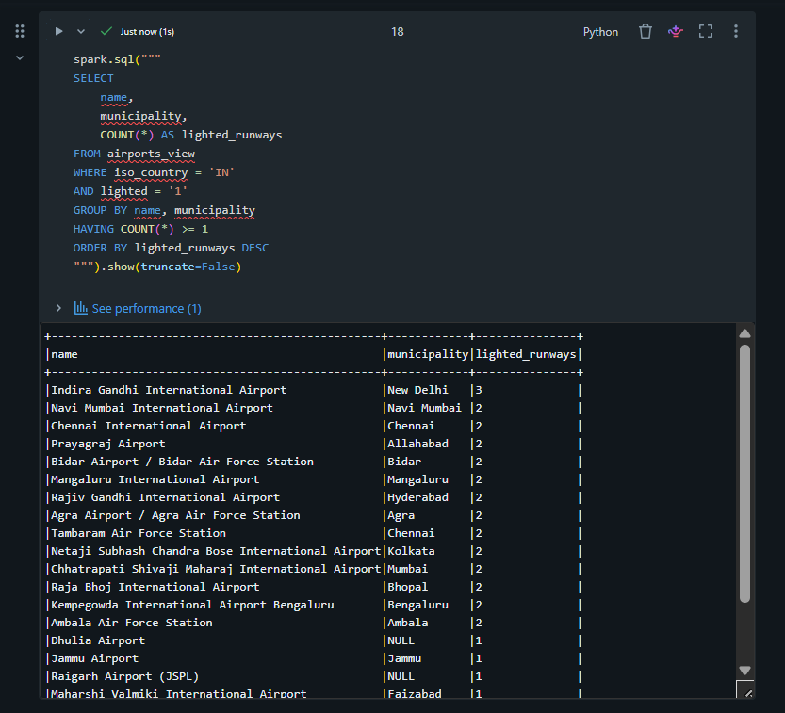
17. list then top 5 airports (by name) with the longest maximum runway ength . display airport name, coutry and max runway length
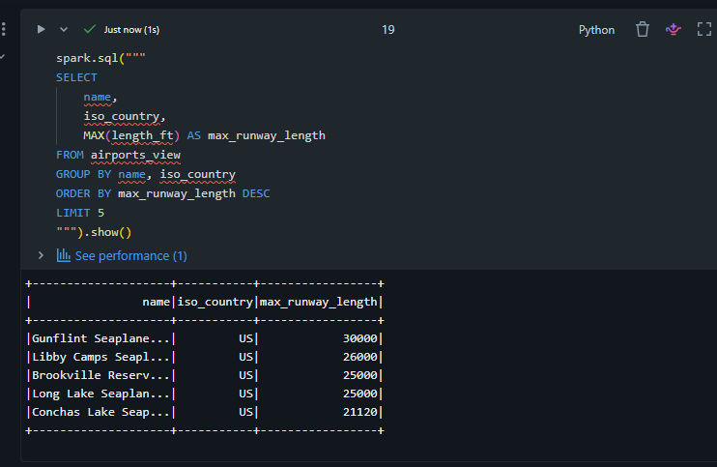
/Volumes/examcatalog/lab/v1
Part d
Save as paqrquet
m. save the df_combined dataframe (with the runway_category colum) as a parquet file to your databrices volume.use overwrite mode

since same id is in both columns
rejoined df and selected columns
